**2024-2028 Colorado State Perkins Plan**

**Executive Summary**

The Carl D. Perkins Act was reauthorized by Congress as the Strengthening Career and Technical Education for the Twenty First Century Act (Perkins V). Perkins V went into effect July 1, 2019. Colorado’s State Plan expires June 30, 2024. Although the federal guidance has not changed, Colorado has made significant progress toward its goals in the 2019-2024 plan and has decided to revise and update the State Perkins Plan based on the current workforce and education landscape in our state along with updated performance targets.

The Colorado State Board for Community Colleges and Occupational Education (SBCCOE) oversees all Career and Technical Education (CTE) programs for the State of Colorado. The Colorado Community College System (CCCS) staff for the SBCCOE has provided leadership in the overall governance of program quality and teacher effectiveness. The Board approves programs and disburses funding to programs at the secondary and postsecondary level. This unique oversight of both secondary and postsecondary level programs gives Colorado an integrated view of the CTE programs that school districts, technical colleges, and community colleges offer.

Planning and development of the State Perkins Plan was an in-depth process involving partners and stakeholders from across the state representing broad diversity of education and workforce programs, agencies, and learners. The 4-step process below shows the significant activities that contributed to development of the State Perkins Plan.

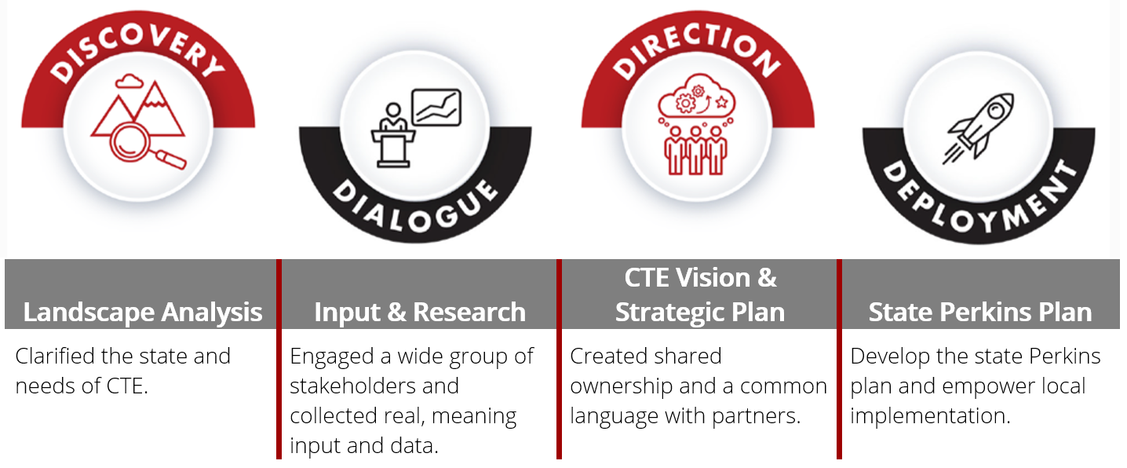

As the State Eligible Agency (SEA), CCCS is responsible for distributing federal Perkins funds to Local Eligible Agencies (LEAs). LEAs may be eligible for state CTE and federal Perkins funds if they complete a Comprehensive Local Needs Assessment (CLNA), develop programs of study, and align CTE programs with local and regional workforce and economic needs, preparing secondary, postsecondary, and adult learners for high-skill, high-wage, or in-demand industries or occupation. Local programs of study must be of sufficient size, scope, and quality in order to be approved to receive CTE and Perkins funds. CCCS provides resources, guidance, and technical assistance to LEAs to support them in the development and implementation of their approved programs of study.

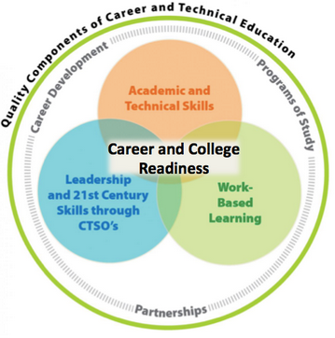Colorado Career and Technical Education (CTE) provides more than 200,000 Colorado learners with the education they need to learn, earn, and live. The CTE system ensures a thriving Colorado economy by providing relevant and rigorous education that is connected, responsive and real. Collaborations with local, statewide, and national business and industry partners help to obtain insight directly from high-skill, high-wage, in-demand industries and occupations. CTE emphasizes academic content, postsecondary and workforce readiness competencies, and technical skills to assist learners in making a seamless transition to further education or employment.

**2024-2028 Strategic CTE Goals Reflected in State Perkins Plan**

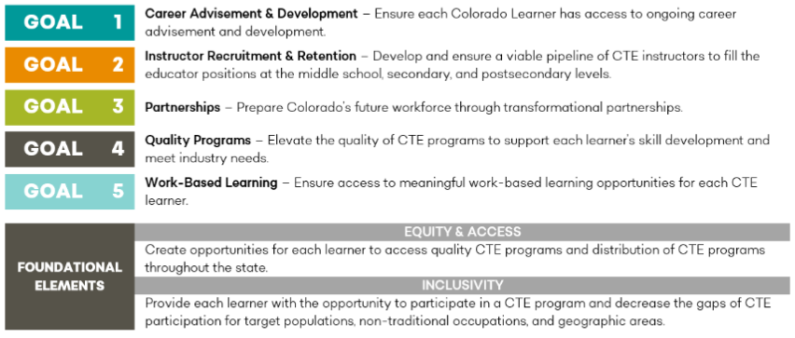

These goals align and supplement other Colorado agency priorities, such as those of the Colorado Office of the Future of Work, the Colorado Department of Education and the Colorado Department of Higher Education master plans, and initiatives led by the Colorado Workforce Development Council such as the Talent Found Work-Based Learning Continuum and sector partnerships work.

**Programs of Study** is a federal Perkins term that requires the opportunity for learners to have access to a roadmap of the on-roads and off-roads for a particular area of study to see what career options, industry recognized certifications, and coursework across the secondary and postsecondary system is available to them should they choose to pursue a particular pathway. This requirement is unique to Perkins law, and builds on the pathways work referenced in the Workforce Innovation and Opportunity Act (WIOA). The State Plan outlines how Colorado aligns middle level, high school, and postsecondary CTE programs to ensure all learners have access to complete programs of study. Through the next four years, CTE program quality will be a focus at all levels to meet the needs of learners and our economy as CTE programs better prepare the current and future workforce. The state plan discusses the details of the Colorado CTE delivery system that serves more than 200,000 CTE learners.

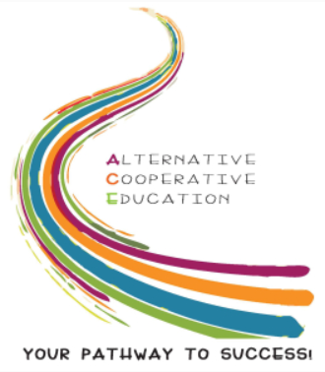**Special Populations** are discussed throughout the state plan as Colorado CTE discusses strategies to develop the academic knowledge and technical skills for special populations. Special populations, as defined by Perkins, are individuals with disabilities; individuals from economically disadvantaged families, including low-income youth and adults; individuals preparing for non-tradition fields (where they are preparing for an occupation where their gender is underrepresented); single parents, including single pregnant women; unemployed individuals; English language learner; homeless individuals per the McKinney-Vento Homeless Assistance Act; youth who are in, or have aged out of the foster care system; and youth with a parent who is a member of the armed forces and is on active duty. One way Colorado provides access for special populations to CTE programs is through Alternative Cooperative Education (ACE). ACE CTE is a multi-occupational pathway that facilitates individualized, developmentally appropriate programming necessary to support CTE students successfully. ACE CTE is inclusive of, but not limited to students identified as special populations.

**Preparing CTE Educators and Faculty**

CTE programs cannot exist without qualified instructors and staff. Colorado CTE programs work closely with the Department of Education and other partners to ensure a viable pipeline of instructors. Additionally, the state plan talks about the commitment in the next four years to support to local CTE providers (school districts and colleges) in identifying and addressing barriers to entry into the teaching profession, such as through the provision of CTE mentors for new instructors and closer partnerships with alternative licensure programs. Finally, retention and ongoing professional development of the current education workforce is critical and the state plan outlines ways CCCS will support professional development activities at the state and local levels such as through existing professional associations, content specific workshops, and new teacher orientations.

**Perkins Funding**

Where there is flexibility in the law as to how federal funds are distributed to local eligible agencies, the state plan outlines specific details of how Colorado will distribute funds. Perkins is a formula grant with 85 percent of the funds distributed going through the federally stipulated formula. Sixty percent of those funds support postsecondary CTE programs, and forty percent supports secondary CTE programs, which also have access to other state dollars supporting CTE (through the Colorado Technical Act). One new requirement in Perkins V is that locals prepare a comprehensive local needs assessment biennially. All Perkins spending must relate to the results of this needs assessment and a wide range of stakeholder voices must be considered. Colorado is completing these needs assessments on a regional basis in coordination with the fourteen identified economic development regions in the state to encourage collaboration and partnership and to avoid overtaxing state and local partners, including business and industry who may have relationships with multiple districts or colleges. Secondary districts participating in Perkins must meet the federal requirements to ‘stand alone’ to receive funds or may participate in a consortium, or regional, grant arrangement. Annually, around 115 school districts participate in consortia.

To encourage innovation and collaboration, the majority of funds not required to be distributed by formula will continue to be awarded on a competitive basis. Proposals must address state identified priorities and demonstrate partnership. There will also be a factor to encourage rural participation in this process and to encourage alignment with the Governor’s economic priorities. The remaining funds not distributed by formula or competition will be divided evenly for distribution to rural grant recipients to ensure a more equitable distribution of grant funds across Colorado.

**Accountability for Results**

The Perkins law requires annual reporting on federally defined performance indicators. The table below details the measures for secondary and postsecondary CTE programs. Through the stakeholder engagement process, Colorado selected work-based learning as its secondary program quality indicator as it aligns most closely with other workforce and education initiatives in our state. To establish baselines and targets for the next four years, goals set in the Every Student Succeeds Act plan managed the Colorado Department of Education and the WIOA Plan managed by the Colorado Workforce Development Council were considered, where applicable. Colorado CTE staff also met with Perkins accountability personnel from other states to consider the broader, national CTE landscape. Nearly every performance indicator in the law measures performance and outcomes based on a learner’s status as a ‘concentrator,’ or having completed a particular minimum portion of a CTE program. Concentration is defined in the federal law and in the state plan. Results in each of these indicators is required to be reported by participants annually, and CCCS provides support in disaggregating the results by special populations and CTE program identifiers to support grant recipients in making equitable and data driven decisions.

**Table of Performance Indicators for Perkins V**

|  |  |  |
| --- | --- | --- |
| **Indicator** | **Secondary Requirement** | **Postsecondary Requirement** |
| Four-Year Graduation Rate | X |  |
| Extended (7-year) Graduation Rate | X |  |
| Academic Proficiency in Reading/Language Arts | X |  |
| Academic Proficiency in Mathematics | X |  |
| Academic Proficiency in Science | X |  |
| Post Program Placement | X |  |
| Non-Traditional* Concentration | X | X |
| Program Quality – Work-based learning** | X |  |
| Postsecondary Retention and Placement |  | X |
| Earned Recognized Postsecondary Credential |  | X |

*Non-traditional refers to occupational fields and their associated CTE program where one gender makes up less than 25% of the workforce (i.e. females in construction; males in nursing).

**Work-based learning activities that meet the federal Perkins definition include those listed on Colorado’s Work-Based Learning Continuum under the ‘Learning Through Work’ and ‘Learning At Work’ headers.